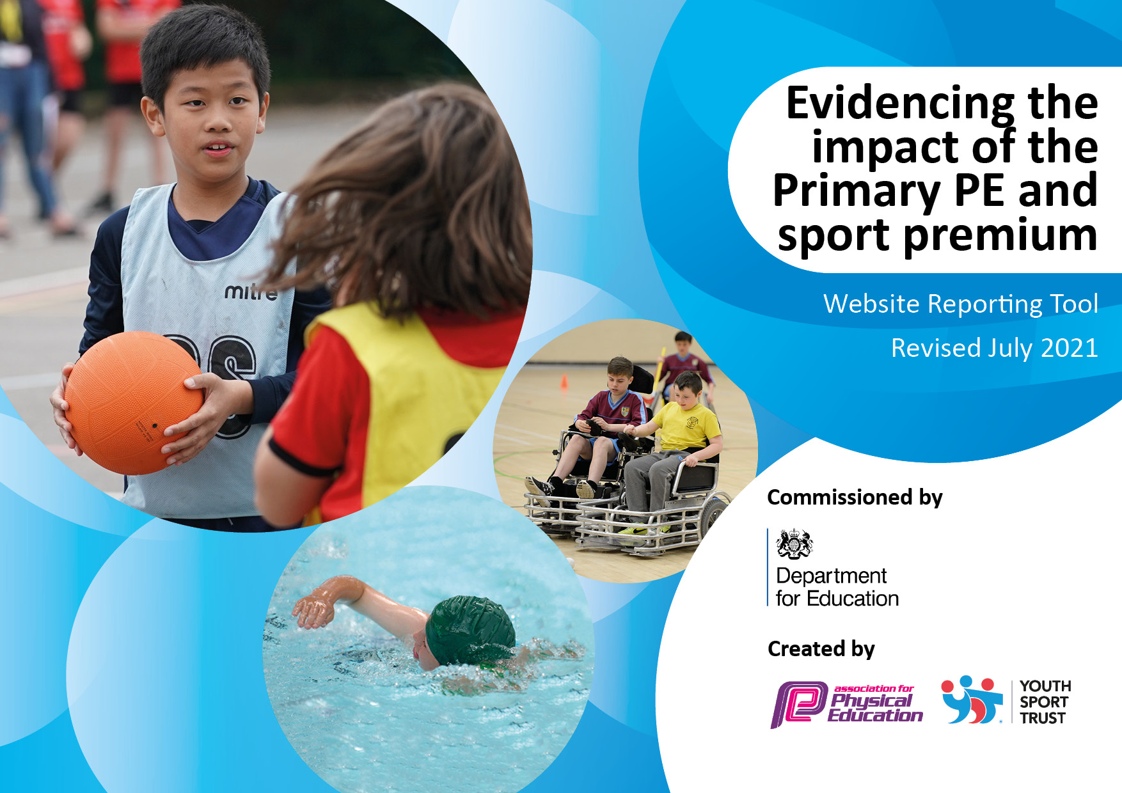
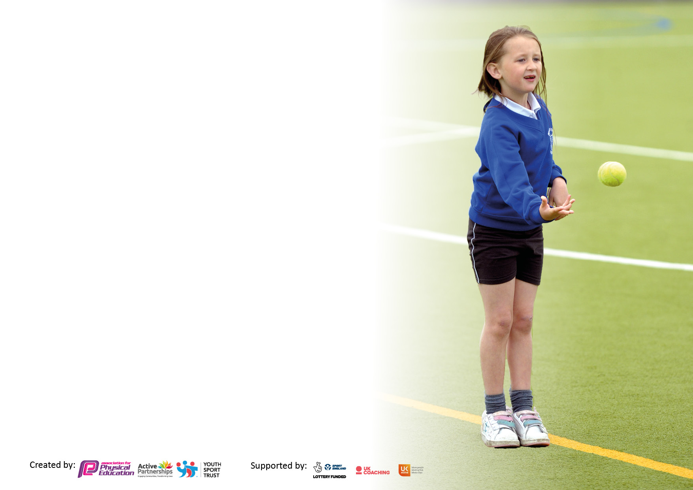

It is important that your grant is used effectively and based on school need. The Education Inspection Framework makes clear there will be a focus on ‘whether leaders and those responsible for governors all understand their respective roles and perform these in a way that enhances the effectiveness of the school’.

Under the Quality of Education Ofsted inspectors consider:
Intent - Curriculum design, coverage and appropriateness
Implementation - Curriculum delivery, Teaching (pedagogy) and Assessment
Impact - Attainment and progress

To assist schools with common transferable language this template has been developed to utilise the same three headings which should make your plans easily transferable between working documents.

Schools must use the funding to make additional and sustainable improvements to the quality of Physical Education, School Sport and Physical Activity (PESSPA) they offer. This means that you should use the Primary PE and sport premium to:

- Develop or add to the PESSPA activities that your school already offer
- Build capacity and capability within the school to ensure that improvements made now will benefit pupils joining the school in future years
- The Primary PE and sport premium should not be used to fund capital spend projects; the school’s budget should fund these.

Pleasevisitgov.ukfortherevisedDfEguidanceincludingthe5keyindicatorsacrosswhichschoolsshoulddemonstrate animprovement.Thisdocumentwillhelpyoutoreviewyourprovisionandtoreportyourspend.DfEencouragesschools to use this template as an effective way of meeting the reporting requirements of the Primary PE and sport premium.

We recommend you start by reflecting on the impact of current provision and reviewing the previous spend.

Schools are required to publish details of how they spend this funding, including any under-spend from 2019/2020, as well as on the impact it has on pupils’ PE and sport participation and attainment. All funding must be spent by 31st July 2022.

We recommend regularly updating the table and publishing it on your website throughout the year. This evidences your ongoing self-evaluation of how you are using the funding to secure maximum, sustainable impact. Final copy must be posted on your website by the end of the academic year and no later than the 31st July 2021. To see an example of how to complete the table please click HERE.
Created by: Supported by:

Details with regard to funding
Please complete the table below.

Total amount carried over from 2021/22 | £0
Total amount allocated for 2022/23 | £16,643
How much (if any) do you intend to carry over from this total fund into 2022/23? | £14,438
Total amount allocated for 2022/23 | £16,580
Total amount of funding for 2022/23. To be spent and reported on by 31st July 2023. | £31,288
Swimming Data
Please report on your Swimming Data below.

Meeting national curriculum requirements for swimming and water safety.

N.B. Complete this section to your best ability. For example you might have practised safe self-rescue techniques on dry land which you can then transfer to the pool when school swimming restarts.
Due to exceptional circumstances priority should be given to ensuring that pupils can perform safe self rescue even if they do not fully meet the first two requirements of the NC programme of study
What percentage of your current Year 6 cohort swim competently, confidently and proficiently over a distance of at least 25 metres?  N.B. Even though your pupils may swim in another year please report on their attainment on leaving primary school at the end of the summer term 2023.  Please see note above | 62.5%
What percentage of your current Year 6 cohort use a range of strokes effectively [for example, front crawl, backstroke and breaststroke]?  Please see note above | 62.5%
What percentage of your current Year 6 cohort perform safe self-rescue in different water-based situations? | 25%
Schools can choose to use the Primary PE and sport premium to provide additional provision for swimming but this must be for activity over and above the national curriculum requirements. Have you used it in this way? | No

Action Plan and Budget Tracking
Capture your intended annual spend against the 5 key indicators. Clarify the success criteria and evidence of impact that you intend to measure to evaluate for pupils today and for the future.

Academic Year: 2022/23 | Total fund allocated: £12,541 | Date Updated: 29.11.23
Key indicator 1: The engagement of all pupils in regular physical activity – Chief Medical Officers guidelines recommend that primary school pupils undertake at least 30 minutes of physical activity a day in school |  |  |  | Percentage of total allocation:
 |  |  |  | 27.69% (£4,591)
Intent | Implementation |  | Impact
Your school focus should be clear what you want the pupils to know and be able to do and about what they need to learn and to consolidate through practice: | Make sure your actions to achieve are linked to your intentions: | Funding allocated: | Evidence of impact: what do pupils now know and what can they now do?  What has changed?: | Sustainability and suggested next steps:
Training for children to become play leaders at playtimes and lunchtimes offer to increase engagement from all children in physical activity.  Training for TA’s MTA’s in effectively managing a positive playground to facilitate the work of the play leaders. | ‘Positive Playtimes’ training (Arena) Children trained in setting up and leading a range of innovative games. | £250 | Pupils developing confidence in running playtime sports. More children active at playtimes. | Continue to train lunchtime play leaders.
Sports/play equipment available to be used at play/lunch times to engage children to be active. | New Equipment purchased, including replacements for broken/ worn equipment. Pupil view included through consultation with children on equipment needed for their preferred activities. | £600 | Children use the equipment to participate in activities and in games that including children with different abilities. | Purchase more playtime equipment.
Fun Fit available to children as a starter to the day to support physical activity and mental health. | Daily Fun Fit session at the start of the school day run by TA. | £1175 | Children are ready to come into lessons and settle into learning following physical activity to address individual needs for physical and mental well-being. | Review of impact each term with adjustments according to needs of individual children.
Skate and scoot sessions reinstated from Pre-Covid times – to facilitate sustained activity during playtime every fortnight. Option for children to also ride to school on those day. | Scooters and helmets purchased for children to use (including PP) | £150 | Alternative activities for participation at playtime. | Other opportunities for developing playtimes to be considered.
Maintenance of play areas so children can engage in physical activity safely. | Maintenance and cleaning of play areas. | £1800 | Children have safe access to play areas. | Renew markings put on playgrounds/ replace surface as required.
PE should not be limited by the lack of suitable spaces for physical activity within and around our school building | Village Hall and Community Hall utilised to facilitate PE activities through the year. | £616 | Access to suitable facilities to enable children to participate in a range of sports and activities. | Working with the local community re availability and access.
Key indicator 2: The profile of PESSPA being raised across the school as a tool for whole school improvement |  |  |  | Percentage of total allocation:
 |  |  |  | 5.88% (£975)
Intent | Implementation |  | Impact
Your school focus should be clear what you want the pupils to know and be able to do and about what they need to learn and to consolidate through practice: | Make sure your actions to achieve are linked to your intentions: | Funding allocated | Evidence of impact: what do pupils now know and what can they now do?  What has changed?: | Sustainability and suggested next steps:
Raise the profile of our PE curriculum in the school and local community. | By highlighting the achievements and awarding the children certificates and awards in whole school assemblies. Also, posting achievements online and on the website. | £0 | Children wanting to achieve and to participate in sports and in PE. And participation is valued, and success is celebrated.
Develop creative ideas on how to incorporate sustainability and climate change into our outdoor education agenda and curriculum, both at school and in the local community. | Sustainability and climate change conference: interactive workshops for staff leader.  Earth Tribe Scheme of Work purchased.  Earth Tribe Leadership Award  Earth Tribe ‘Rewild’ Programme | £0  £350  £250  £375 | Sustainability Action Plan to be developed for school and work in collaboration with the local community.  Science based schemes of work to be delivered outdoors.  Children to be climate change ambassadors across school; leading activities in the outdoors.  Development of an outdoor area in response to concerns raised by the children re climate change with a focus on re-wilding.
Encourage children to drink water regularly throughout the day and refill bottles with water, when required. | Children drink water from their own school bought water bottle and making the children aware the importance of drinking water alongside physical exercise. |  | Children drinking fresh, cooled water more regularly. Promoting healthy lifestyles. | Purchase spare water bottles for children to encourage drinking water.
In KS1 children to have a healthy snack in the morning to support energy levels and health. | Fresh fruit is delivered weekly. | £TBC | Children eating fresh fruit regularly. Promoting healthy lifestyles. | To provide KS2 fruit.  Grow our own fruit and vegetables in the garden.

Key indicator 3: Increased confidence, knowledge and skills of all staff in teaching PE and sport |  |  |  | Percentage of total allocation:
 |  |  |  | 38.75% (£6,425)
Intent | Implementation |  | Impact
Your school focus should be clear | Make sure your actions to | Funding | Evidence of impact: what do | Sustainability and suggested
what you want the pupils to know | achieve are linked to your | allocated: | pupils now know and what | next steps:
and be able to do and about | intentions: |  | can they now do? What has
what they need to learn and to |  |  | changed?:
consolidate through practice:
Wider range of sports on offer for PE curriculum and afterschool clubs to broaden sporting experiences and increase pupil engagement both in and out of school time. | Wider PE sports delivered by coaches from Arena Sports | £4250 & £450 (SLA) | Build activity levels, physical skills, strength and co-ordination. Increased enjoyment and participation in sports in and out of school time. | Curriculum review to plan for 2024/25
Physical activity increased through maths related activities. Planning and activities on website for teacher use. | Teach Active – maths purchased. | £575 | Maths, physical activity and enjoyment seen through the children. | Maths Trail in a Day.
Staff leader to be skilled in leading and delivering Wild Tribe learning across the school. | Wild Tribe Learning Subject Leaders Course  4 x days supply cover | £550  £600 | Raise standards and increase engagement in literacy alongside encouraging children to be more active and to access the outdoors positively.
Key indicator 4: Broader experience of a range of sports and activities offered to all pupils |  |  |  | Percentage of total allocation:
 |  |  |  | 12.97% (£2,150)
Intent | Implementation |  | Impact
Your school focus should be clear | Make sure your actions to | Funding | Evidence of impact: what do | Sustainability and suggested
what you want the pupils to know | achieve are linked to your | allocated: | pupils now know and what | next steps:
and be able to do and about | intentions: |  | can they now do? What has
what they need to learn and to |  |  | changed?:
consolidate through practice:
Provide wider activities for all ages and for children to learn new skills and improve their wellbeing, teamwork, resilience, and physical ability. | Healthy Hearts, Healthy Minds (Arena)  Wellbeing and mental health sessions at school with all children for all year groups.  Mini First Aid – Healthy Minds | £325  £375 | Children developed a wider range of skills and enjoyment of learning in the outdoors and being physically active. Also, techniques to maintain a healthy lifestyle and mind. | To offer Wild Tribe Achievement Award (Mini Duke of Edinburgh) next year to Y5/6
Dance project linked to singing. Staff training working alongside dance specialist. | Sea shanty dance project lead by dance specialist, Sarah Waller to link with Songfest 2024 theme. | £800 | Community event for parents to attend to share and celebrate creativity through dance. | Curriculum review to include dance project for 2024/25.
Outdoor and adventurous opportunities for KS2 children. | Day of activities at Adventure Bude for KS2 children.  Weekly Sailing lessons in summer term 2024 | £400 | Children develop physical skills, confidence, resilience, teamwork through O&A activities. | Residential offer to follow.
Experiencing a professional sports game and venue. | Trip to Plymouth City Patriots Basketball match | £250 | Children inspired by professional sport and motivated to increase engagement, to try new sports. | Other professional sport opportunities to be identified.

Key indicator 5: Increased participation in competitive sport |  |  |  | Percentage of total allocation:
 |  |  |  | %
Intent | Implementation |  | Impact
Your school focus should be clear | Make sure your actions to | Funding | Evidence of impact: what do | Sustainability and suggested
what you want the pupils to know | achieve are linked to your | allocated: | pupils now know and what | next steps:
and be able to do and about | intentions: |  | can they now do? What has
what they need to learn and to |  |  | changed?:
consolidate through practice:
For all children to have the opportunity to compete at sports in the local community. | Participation in sport festivals and tournaments at Budehaven Community School and SJS schools.  Arena membership to gain access to further competitive sports. | £0 | Increased involvement in competitive sports. Children engaged in participating in wider sports outside of school in competition through a diary of sports delivered by Budehaven & SJS. | Continue to build this and increase participation and a wider variety of sports.
Cross country competitions – Landrake & Deli Farm Run (Spring Term 2024) | Participation in competitions against other local schools. | £TBC | Children engaged in participating in wider sports outside of school

Signed off by
Head Teacher: | Sara Haden
Date: | 30/11/23
Subject Leader: | Ben Rix
Date: | 30/11/23
Governor: | Kate Evans
Date: | 30/11/23

